

Predictive Maintenance Analysis Using AI4I 2020 Industrial Dataset

Based
on
Curriculum Project on Minor Track Project (Data Analytics)
T.Y.B.Sc-Statistics Data Science

by

- Nikita Dalvi
SRN:31231066

Under the Mentorship
of
Dr. Mahfooz Alam & Dr. Jagadish V. Tawade

Department of Mathematics and Statistics,
Faculty of Science and Technology,
Vishwakarma University, Pune
AY: 2025-26

ABSTRACT
Predictive maintenance is an important application of data analytics in modern manufacturing industries. Machine failures cause unexpected downtime, production loss, and high maintenance cost. This project aims to analyze industrial machine data and develop predictive models to identify potential failures before they occur.
The AI4I 2020 Predictive Maintenance Dataset was used, containing 10,000 records of machine sensor data such as air temperature, process temperature, torque, rotational speed, tool wear, and machine type. Exploratory Data Analysis showed that tool wear, torque, and temperature are major factors affecting machine failure.
Several machine learning models were applied including Logistic Regression, Decision Tree, and Random Forest. Random Forest achieved the best accuracy of approximately 96–98%. Class imbalance was handled using SMOTEENN to improve prediction of rare failures. Feature engineering techniques were also used to improve model performance.
The results demonstrate that predictive maintenance models can help industries detect failures early, reduce downtime, improve productivity, and lower maintenance costs.

TABLE OF CONTENTS

Chapter | Title | Page No.
 | ABSTRACT | i
Chapter 1 | INTRODUCTION | 1
1.1 | Background | 1
1.2 | Importance of Predictive Maintenance | 2
1.3 | Problem Statement | 3
1.4 | Objectives | 4
1.5 | Scope of the Study | 5
Chapter 2 | METHODOLOGY | 8
2.1 | Introduction | 8
2.2 | Overview of Methodology | 9
2.3 | Description of Method / Model Used | 10
Chapter 3 | DATA DESCRIPTION | 14
3.1 | Dataset Source | 14
3.2 | Dataset Structure | 16
3.3 | Failure Types | 17
3.4 | Data Quality Assessment | 18
Chapter 4 | RESULTS AND DISCUSSION | 18
5.1 | Introduction | 18
5.2 | Failure Type Distribution Analysis | 19
5.3 | Tool Wear Analysis | 20
5.4 | Torque Analysis | 21
5.5 | Temperature Analysis | 22
5.6 | Correlation Heatmap Analysis | 23
5.7 | Machine Type Analysis | 24
5.8 | Feature Importance Analysis | 25
5.9 | Confusion Matrix Analysis | 26
5.10 | Machine Learning Model Performance | 27
5.11 | Overall Insights | 28
5.12 | Practical Industrial Applications | 29
Chapter 5 | CONCLUSION | 30
6.1 | Conclusions | 30
6.2 | Scope for Future Work | 32
6.3 | Final Statement | 33
 | REFERENCES | 34
 | APPENDIX | 36
A.1 | Python Code / Project Implementation | 36

CHAPTER 1
INTRODUCTION
1.1 Background
Modern industries depend on machines for production. Machine breakdown leads to production loss and financial damage. Therefore, maintenance planning is very important.
Traditional maintenance strategies:
- Reactive Maintenance – repair after breakdown
- Preventive Maintenance – repair at fixed intervals
Both methods are inefficient because they do not consider actual machine condition.
Predictive maintenance uses machine learning and data analytics to predict failure before it occurs.
1.2 Importance of Predictive Maintenance
Benefits include:
• Reduced downtime
• Lower repair cost
• Better machine lifespan
• Improved worker safety
• Better production planning
• Increased efficiency
Predictive maintenance is used in:
• Manufacturing
• Aviation
• Automotive
• Energy sector
• Railways
1.3 Problem Statement
Machine failures cause major financial losses in industries. Traditional maintenance methods cannot detect failures early. There is a need for data-driven predictive maintenance models that analyze machine sensor data and predict failures before they happen.

1.4 Objectives
- Perform Exploratory Data Analysis on industrial dataset
- Identify key variables affecting machine failure
- Apply machine learning models
- Compare model performance
- Suggest maintenance strategies

1.5 Scope of the Study
This project focuses on predictive maintenance using structured historical machine data. It identifies patterns in machine parameters and builds predictive models.
The study can be extended to real-time monitoring systems using IoT sensors.

CHAPTER 2 – METHODOLOGY
2.1 Introduction
This chapter explains the methodology followed in this project to analyze machine sensor data and predict machine failures using machine learning techniques. A structured data analytics process was used to ensure accurate analysis and reliable results.
The methodology included data collection, preprocessing, exploratory data analysis, feature engineering, model building, and evaluation.

2.2 Overview of Methodology
The project followed the following steps:
- Data Collection
- Data Cleaning
- Exploratory Data Analysis
- Feature Engineering
- Machine Learning Modeling
- Model Evaluation and Interpretation
This structured approach helped in understanding machine behavior and building an accurate predictive maintenance model.

2.3 Description of Method / Model Used
In this project, supervised machine learning techniques were used to predict machine failure types based on industrial sensor data. The main models used were Logistic Regression, Decision Tree, and Random Forest Classifier.
Random Forest Classifier
Random Forest is an ensemble machine learning algorithm that builds multiple decision trees and combines their predictions to improve accuracy. Each tree is trained on a random subset of data and features, which reduces overfitting and improves generalization.
Random Forest was selected because:
• It handles nonlinear relationships effectively
• It works well with noisy industrial data
• It reduces overfitting compared to single decision trees
• It provides feature importance ranking
• It performs well on classification problems
Machine failure depends on multiple parameters such as temperature, torque, and tool wear. Random Forest can capture these complex relationships effectively.
Decision Tree
Decision Tree was used as an interpretable model that splits data into decision rules based on feature values. However, single decision trees may overfit data.

CHAPTER 3 – DATA DESCRIPTION
3.1 Dataset Source
The dataset used in this project is the AI4I 2020 Predictive Maintenance Dataset, obtained from Kaggle. It is a synthetic but realistic dataset designed to simulate industrial machine behavior. The dataset contains sensor readings from industrial machines and includes information about machine failures.
Total Records: 10,000
Number of Features: 10+ machine parameters
The dataset is widely used in research and academic projects related to predictive maintenance.

3.2 Dataset Structure
The dataset consists of numerical and categorical variables representing machine conditions. Each row represents a machine observation at a specific time.
Main variables include:
Variable | Description
Air temperature [K] | Ambient temperature around machine
Process temperature [K] | Internal machine temperature
Rotational speed [rpm] | Speed of machine spindle
Torque [Nm] | Load applied to machine
Tool wear [min] | Usage time of tool
Machine Type | L, M, H machine category
Failure Type | Target variable

Machine type categories:
• L – Low quality machine
• M – Medium quality machine
• H – High quality machine

3.3 Failure Types
The dataset contains different failure categories:
• Tool Wear Failure (TWF)
• Heat Dissipation Failure (HDF)
• Power Failure (PWF)
• Overstrain Failure (OSF)
• Random Failure (RNF)
Most machines have no failure, creating class imbalance. This reflects real industrial environments where failures are rare.

3.4 Data Quality Assessment
Before analysis, data quality was checked:
• No missing values found
• No duplicate records detected
• Data types verified
• Outliers analyzed
Feature engineering was applied:
• Temperature Difference = Process Temperature – Air Temperature
• Torque-Speed Interaction Feature
These features improved model accuracy.

CHAPTER 4 – RESULTS AND DISCUSSION
5.1 Introduction
The purpose of this chapter is to analyze the results obtained from Exploratory Data Analysis and machine learning modeling using the AI4I Predictive Maintenance Dataset. The results help understand machine behavior, identify major causes of machine failure, and evaluate the effectiveness of predictive maintenance models.
Predictive maintenance analysis is important because it helps industries prevent unexpected machine breakdown, reduce maintenance costs, and improve production efficiency.

5.2 Failure Type Distribution Analysis
Graph: Bar Chart (Failure Type Distribution)
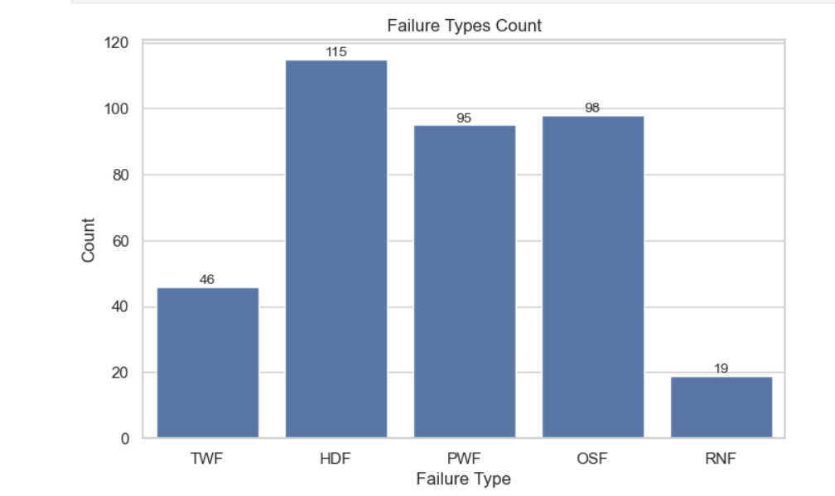
Description:
- This graph shows the frequency of different machine failure types.
- The x-axis represents failure categories such as Tool Wear Failure, Heat Dissipation Failure, Power Failure, Overstrain Failure, and Random Failure.
- The y-axis represents the number of occurrences.
- Most observations belong to the non-failure (normal) category, while failure types have very low counts.
Observation:
- Failures are very rare compared to normal machine operations.
Interpretation:
- This indicates a class imbalance problem, where failure cases are limited.
Conclusion:
- Special techniques like data balancing are required for better prediction.

5.3 Distribution of Process Temperature (Histogram with KDE)
Graphs: Histogram + Boxplot
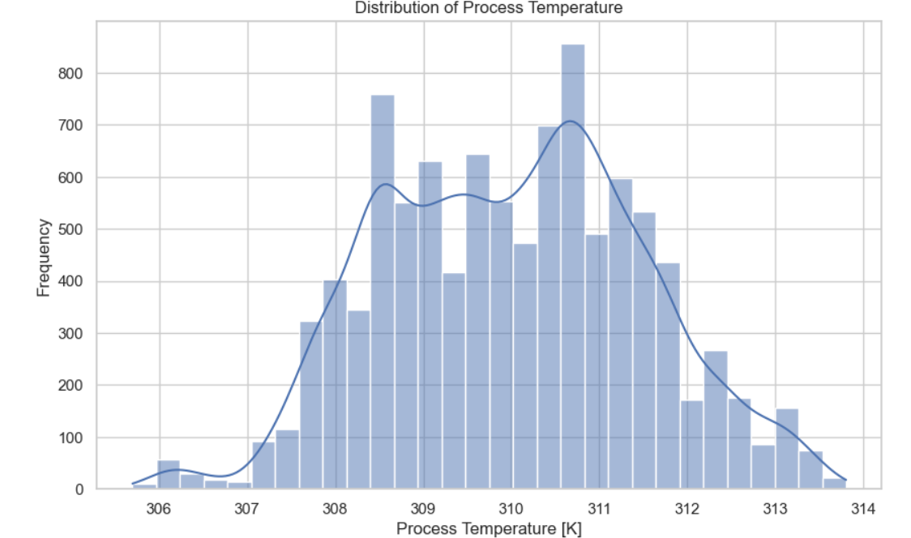
Description:
- The graph represents the distribution of process temperature (in Kelvin) across all machine observations.
- The x-axis shows the process temperature values, ranging approximately from 306 K to 314 K.
- The y-axis represents the frequency of observations.
- The histogram bars show how often each temperature range occurs, while the smooth curve (KDE line) indicates the overall distribution pattern.
- The graph appears to follow a bell-shaped (normal) distribution, with most values concentrated around the center.
Observation:
- Most process temperature values lie between 308 K and 312 K.
- The peak of the distribution is around 310–311 K, indicating the most common operating temperature.
- Very few machines operate at extremely low or high temperatures.
Interpretation:
- The process temperature is relatively stable and operates within a controlled range.
- The normal distribution suggests that the machine system maintains consistent thermal conditions.
- Any deviation from this normal range may indicate abnormal behavior or potential failure conditions.
Conclusion:
- Process temperature is an important parameter for monitoring machine health.
- Maintaining temperature within the optimal range can help prevent overheating and failures.
- Sudden spikes or drops in temperature should be considered as warning signals for maintenance.

5.4Tool Wear Trend (Line Plot)
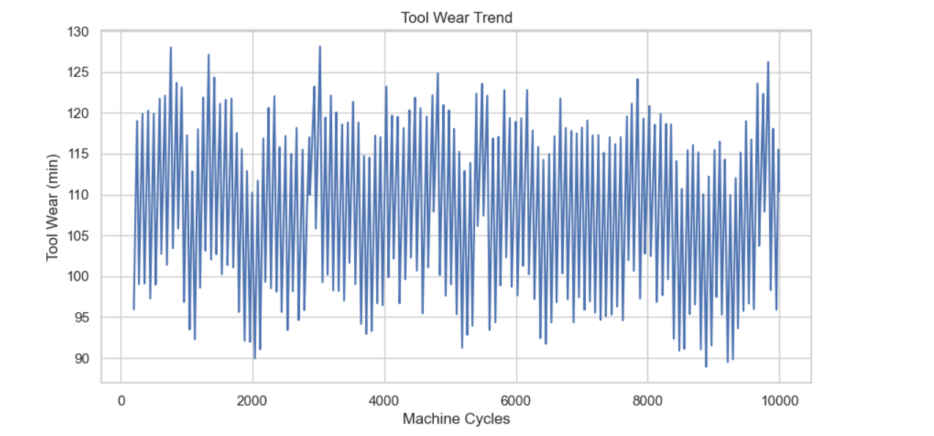
Description:
- This graph represents the variation of tool wear over machine cycles.
- The x-axis shows the number of machine cycles, ranging from the beginning to around 10,000 cycles.
- The y-axis represents tool wear values (in minutes).
- Each point on the graph indicates the tool wear at a specific cycle, and the line connects these points to show the overall trend.
- The graph displays frequent fluctuations in tool wear values, with peaks and dips observed throughout the cycles.
- Tool wear values generally range between 90 and 130 units, indicating variability in tool condition over time.
Observation:
- Tool wear does not increase linearly; instead, it shows continuous fluctuations.
- There are multiple peaks where tool wear reaches higher values (~125–130).
- There are also dips where tool wear drops closer to ~90–95.
- No clear upward or downward trend is consistently maintained.
Interpretation:
- The fluctuating pattern suggests that tool wear is influenced by varying operational conditions such as load, speed, and temperature.
- Sudden increases in tool wear may indicate periods of heavy usage or stress on the machine.
- Drops in tool wear values may indicate tool replacement, maintenance, or recalibration.
- The absence of a smooth increasing trend implies that maintenance actions may already be taking place intermittently.
Conclusion:
- Tool wear is dynamic and varies significantly across machine cycles.
- Continuous monitoring is essential to detect abnormal spikes in wear.
- Predictive maintenance systems can use this trend to schedule timely tool replacement and avoid unexpected failures.

5.5 Graph: Failure Type Distribution (Pie Chart)
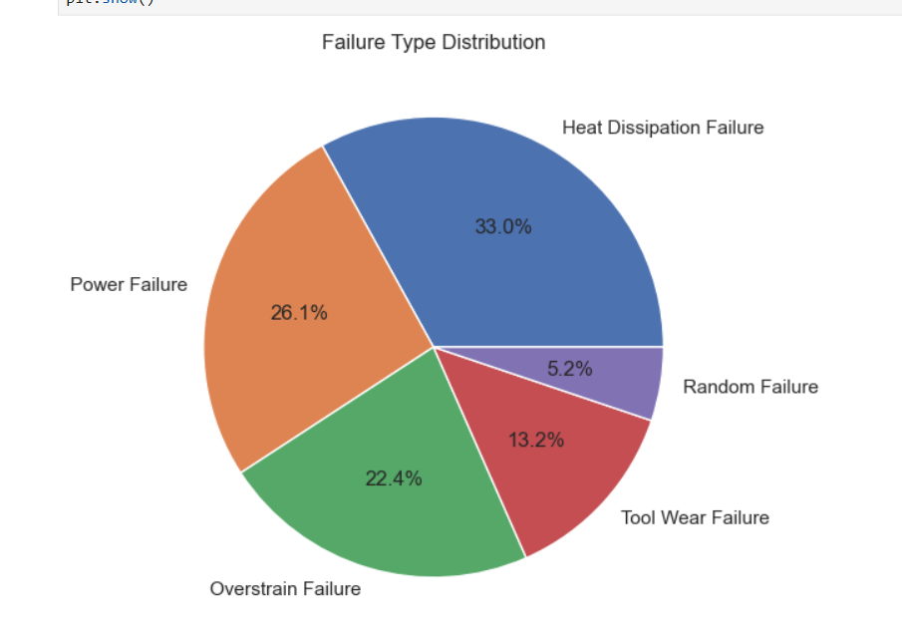
Description:
- This pie chart represents the proportion of different types of machine failures in the dataset.
- Each slice of the pie corresponds to a specific failure type, including Heat Dissipation Failure (HDF), Power Failure (PWF), Overstrain Failure (OSF), Tool Wear Failure (TWF), and Random Failure (RNF).
- The size of each slice indicates the relative percentage contribution of that failure type to the total number of failures.
- Heat Dissipation Failure occupies the largest portion of the chart (approximately 33%), followed by Power Failure (~26.1%) and Overstrain Failure (~22.4%).
- Tool Wear Failure accounts for around 13.2%, while Random Failure represents the smallest portion at approximately 5.2%.
Observation:
- Heat Dissipation Failure is the most frequent failure type.
- Random Failure occurs the least.
- The distribution is uneven, with a few dominant failure types.
Interpretation:
- The high percentage of Heat Dissipation Failure indicates that overheating and cooling inefficiencies are major issues in machine operation.
- Power Failure and Overstrain Failure also contribute significantly, suggesting electrical and mechanical stress factors.
- The low percentage of Random Failure indicates that most failures are predictable and linked to specific causes.
Conclusion:
- Thermal management systems should be prioritized to reduce failures.
- Preventive maintenance strategies should focus on dominant failure types.
- Since most failures are not random, predictive maintenance models can effectively identify and prevent them.

5.6 Graph: Machine Type vs Failure (Bar Chart)
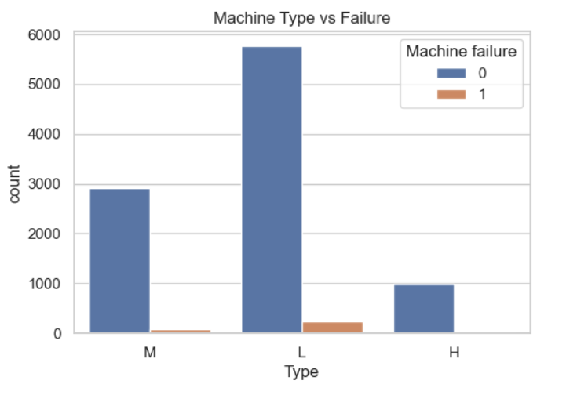
Description:
- This bar chart illustrates the relationship between machine type and machine failure occurrence.
- The x-axis represents different machine types: M (Medium), L (Low), and H (High) quality machines.
- The y-axis represents the count of observations for each category.
- Each machine type has two bars:
  - 0 (No Failure) shown in blue
  - 1 (Failure) shown in orange
- The graph shows that the majority of observations for all machine types fall under the non-failure category (0).
- Among all machine types, Low-quality (L) machines have the highest number of total observations and also the highest number of failures.
- Medium (M) machines show moderate counts, while High-quality (H) machines have the lowest number of failures.
Observation:
- Failures are significantly lower than non-failure cases across all machine types.
- Low-quality machines show the highest number of failures.
- High-quality machines show very few or almost no failures.
Interpretation:
- Machine quality has a direct impact on reliability and failure rate.
- Low-quality machines are more prone to breakdown due to inferior materials, design, or higher stress levels.
- High-quality machines are more robust and operate efficiently with minimal failure occurrences.
Conclusion:
- Improving machine quality can significantly reduce failure rates.
- Industries should prioritize investment in high-quality machines for better performance and lower maintenance costs.
- Machine type is an important factor in predictive maintenance models.

5.7 Graph: Failure Rate by Tool Wear Level (Bar Chart)

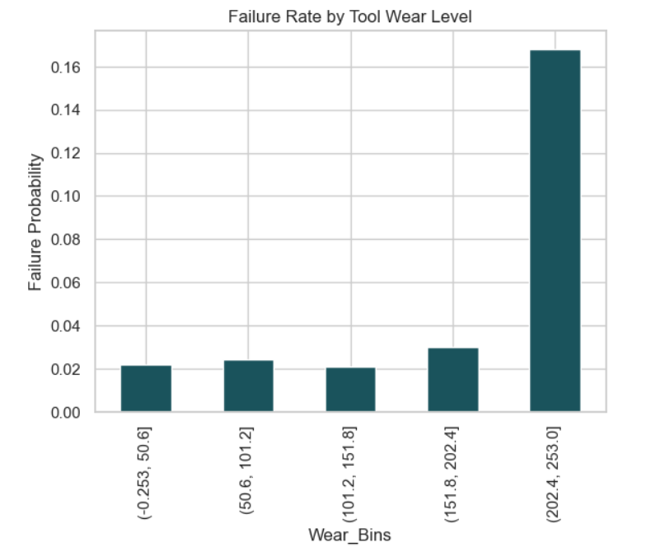
Description:
- This bar chart illustrates the relationship between tool wear levels and the probability of machine failure.
- The x-axis represents different tool wear intervals (bins), categorized into ranges such as low, moderate, and high wear levels.
- The y-axis represents the failure probability, indicating the likelihood of machine failure within each wear range.
- Each bar corresponds to a specific tool wear range and shows how failure probability changes as wear increases.
- The graph shows a gradual increase in failure probability across higher wear bins, with a sharp rise in the highest wear category.
Observation:
- Failure probability is low and relatively stable for lower tool wear ranges.
- A slight increase is observed in moderate wear levels.
- A significant spike in failure probability is seen in the highest wear bin (above ~200 units).
Interpretation:
- At lower tool wear levels, machines operate efficiently with minimal risk of failure.
- As tool wear increases, mechanical stress and inefficiency also increase, leading to a higher chance of failure.
- The sharp increase in the final wear bin indicates a critical threshold, beyond which the likelihood of failure rises dramatically.
- This suggests that tool degradation reaches a point where the machine can no longer function reliably.
Conclusion:
- Tool wear has a strong and direct impact on machine failure probability.
- There exists a critical wear limit after which failure risk increases significantly.
- Preventive maintenance should be scheduled before reaching high wear levels.
- Monitoring tool wear can help in early detection and avoidance of sudden machine breakdowns.

  - Graph: Tool Wear vs Machine Failure (Boxplot)

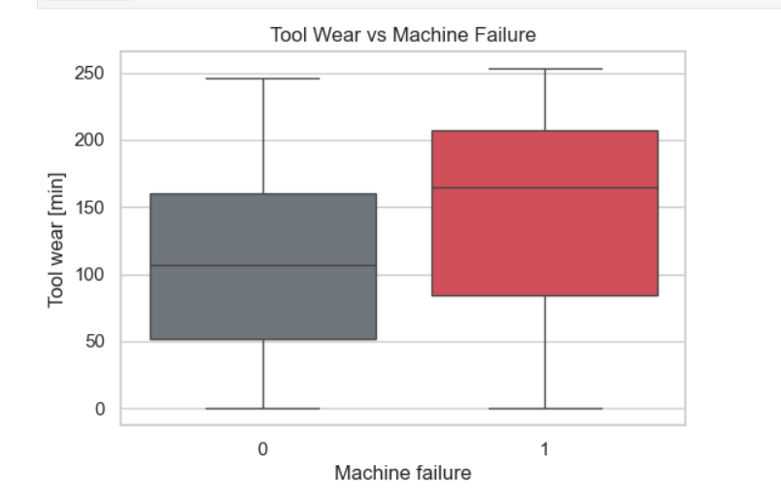Description:
- This boxplot illustrates the relationship between tool wear and machine failure status.
- The x-axis represents machine condition:
  - 0 = No Failure
  - 1 = Failure
- The y-axis represents tool wear values (in minutes).
- Each box shows the distribution of tool wear using:
  - Median (center line)
  - Interquartile Range (IQR) (the box)
  - Whiskers indicating spread of data
- The boxplot for failed machines (1) is positioned higher compared to non-failed machines (0), indicating higher wear levels.
- The spread of values is also wider for failed machines, showing greater variability.
Observation:
- The median tool wear for failed machines is significantly higher than for non-failed machines.
- Failed machines show a wider range of tool wear values.
- Some overlap exists, but higher wear values are more concentrated in failure cases.
Interpretation:
- As tool wear increases, the likelihood of machine failure also increases.
- Higher variability in failed machines suggests that failure can occur at different wear levels depending on other factors.
- The overlap indicates that tool wear alone is not the only factor, but it is a major contributor.
Conclusion:
- Tool wear is a critical parameter influencing machine failure.
- Machines with higher tool wear are more prone to breakdown.
- Regular monitoring and timely replacement of tools can significantly reduce failure risk.
- Tool wear should be included as a key feature in predictive maintenance models.

5.9 Graph: Temperature Difference vs Machine Failure (Boxplot)

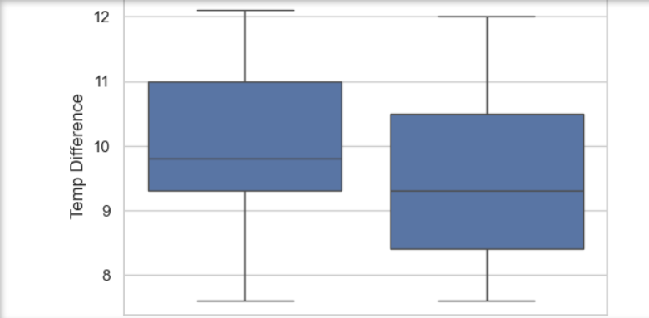
Description:
- This boxplot shows the relationship between temperature difference and machine failure status.
- The x-axis represents machine condition:
  - 0 = No Failure
  - 1 = Failure
- The y-axis represents the temperature difference, which is the difference between process temperature and air temperature.
- Each boxplot displays:
  - The median (central line)
  - The interquartile range (IQR) (box)
  - The whiskers indicating spread of values
- Both categories show overlapping distributions, but there are noticeable differences in central tendency and spread.
Observation:
- The median temperature difference for non-failure cases is slightly higher than for failure cases.
- Failure cases show a wider spread of values, especially toward lower temperature differences.
- There is overlap between the two groups, but variability is higher in failure conditions.
Interpretation:
- Temperature difference alone does not strongly separate failure and non-failure cases.
- However, variations and inconsistencies in temperature difference may contribute to machine instability.
- A wider spread in failure cases suggests that irregular cooling performance may lead to failures.
- Both extremely high and fluctuating temperature differences can affect machine performance.
Conclusion:
- Temperature difference is an important but not sole indicator of machine failure.
- It should be analyzed along with other factors such as tool wear and torque.
- Monitoring cooling efficiency and maintaining stable temperature conditions can help reduce failure risk.

5.10 Graph: Torque vs Rotational Speed (Scatter Plot)
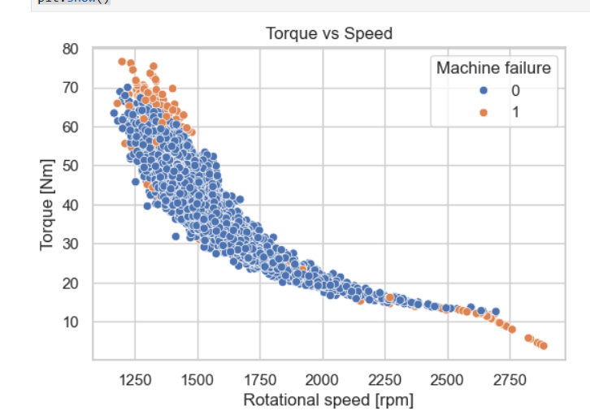
Description:
- This scatter plot illustrates the relationship between torque (Nm) and rotational speed (rpm) of the machine.
- The x-axis represents rotational speed (in revolutions per minute - rpm).
- The y-axis represents torque (in Newton-meters - Nm).
- Each point represents an individual machine observation.
- The data points are color-coded based on machine condition:
  - Blue (0) = No Failure
  - Orange (1) = Failure
- The plot shows a clear inverse relationship between torque and speed, forming a downward-sloping pattern.
Observation:
- As rotational speed increases, torque decreases.
- Most failure points (orange) are concentrated in:
  - High torque & low speed region
  - Extremely low torque & very high speed region
- Normal operation points (blue) are densely clustered in the middle range.
Interpretation:
- The inverse relationship indicates that machines require higher torque at lower speeds and lower torque at higher speeds.
- High torque at low speeds suggests heavy load conditions, which can lead to overstrain and failure.
- Extremely high speeds with low torque may indicate instability or abnormal operating conditions.
- Failures tend to occur at extreme operating conditions rather than normal ranges.
Conclusion:
- Both torque and speed are critical parameters influencing machine performance.
- Operating outside optimal torque-speed ranges increases failure risk.
- Monitoring this relationship helps in identifying abnormal machine behavior.
- This graph is highly useful for predictive maintenance and early failure detection.

5.11 Graph: Torque Density by Machine Failure (KDE Plot)
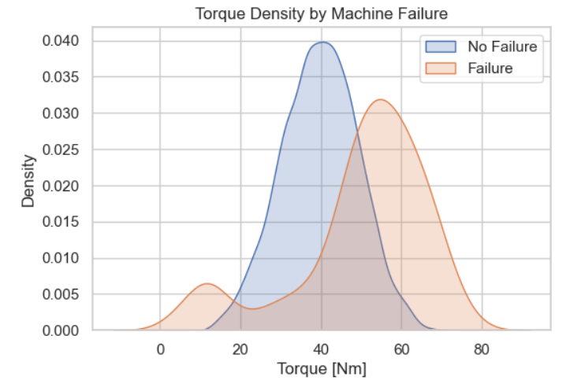
Description:
- This graph represents the distribution (density) of torque values for machines under two conditions: No Failure (0) and Failure (1).
- The x-axis shows torque values (in Newton-meters, Nm), while the y-axis represents the density, indicating how frequently certain torque values occur.
- The graph uses smooth curves (Kernel Density Estimation - KDE) to show the probability distribution of torque.
- The blue curve represents machines with no failure, and the orange curve represents machines that experienced failure.
- The two distributions overlap partially but show noticeable differences in their peak positions and spread.
Observation:
- The no-failure distribution peaks around 35–45 Nm, indicating normal operating torque range.
- The failure distribution peaks at a higher range, around 50–65 Nm.
- Failure cases show a wider spread and extend to higher torque values.
- There is some overlap between the two distributions, especially in the mid-range.
Interpretation:
- Machines operating at higher torque levels are more likely to experience failure.
- The shift of the failure curve toward higher torque values indicates that increased mechanical load contributes to failures.
- The overlap suggests that torque alone cannot fully determine failure but is a strong contributing factor.
- The wider spread in failure cases indicates variability in failure conditions.
Conclusion:
- Torque is a critical parameter influencing machine failure.
- Higher torque levels significantly increase the risk of breakdown.
- Monitoring torque distribution helps identify abnormal operating conditions.
- This graph supports the use of torque as an important feature in predictive maintenance models.

5.12 Graph: Air Temperature Distribution (Histogram)
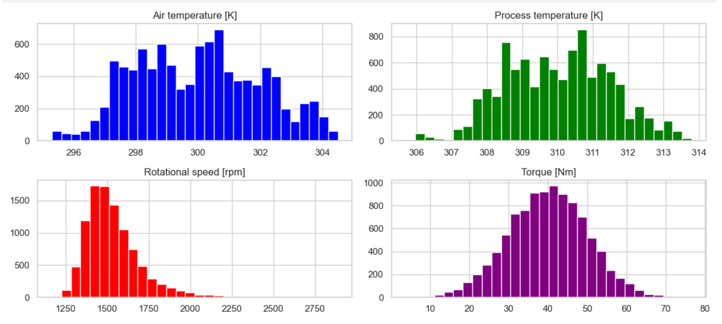
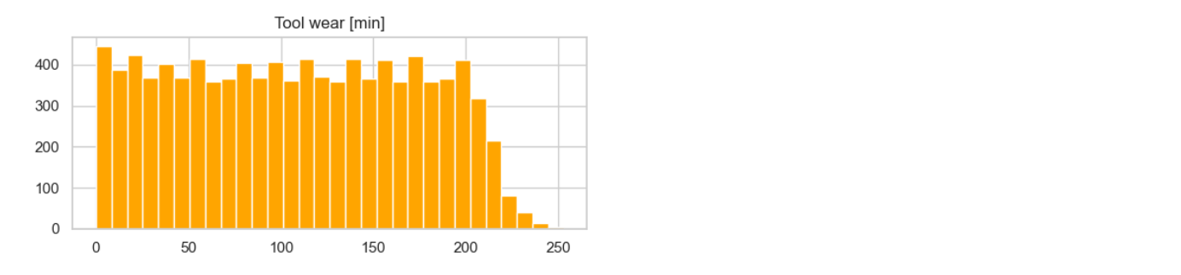
Description:
- This histogram represents the distribution of air temperature values (in Kelvin).
- The x-axis shows air temperature values ranging approximately from 295 K to 305 K.
- The y-axis represents the frequency of observations.
- The bars indicate how frequently each temperature range occurs.
- The distribution appears approximately normal (bell-shaped), centered around a mean value.
Observation:
- Most air temperature values lie between 298 K and 302 K.
- The peak frequency occurs near 300 K.
- Extreme values (very low or high temperatures) are less frequent.
Interpretation:
- Air temperature remains relatively stable within a narrow range.
- This indicates a controlled environmental condition around the machine.
Conclusion:
- Stable air temperature supports consistent machine performance.
- Sudden variations may indicate environmental or system issues.

Graph: Process Temperature Distribution (Histogram)
Description:
- This histogram shows the distribution of process temperature (in Kelvin).
- The x-axis represents temperature values from approximately 306 K to 314 K.
- The y-axis shows the frequency of observations.
- The distribution is bell-shaped, indicating a normal pattern with a central peak.
Observation:
- Most values fall between 308 K and 312 K.
- The peak occurs around 310–311 K.
Interpretation:
- Machines operate within a stable thermal operating range.
- Process temperature is tightly controlled.
Conclusion:
- Maintaining this temperature range is crucial for machine efficiency and safety.

Graph: Rotational Speed Distribution (Histogram)
Description:
- This histogram shows the distribution of rotational speed (rpm).
- The x-axis represents speed values ranging approximately from 1200 rpm to 2800 rpm.
- The y-axis indicates frequency.
- The distribution is slightly right-skewed, with most values concentrated in the lower range.
Observation:
- Most machines operate between 1300 rpm and 1700 rpm.
- Higher speeds are less frequent.
Interpretation:
- Machines are generally operated at moderate speeds for efficiency and safety.
- High-speed operation is less common due to higher risk and stress.
Conclusion:
- Maintaining moderate rotational speed reduces wear and failure risk.
Graph: Torque Distribution (Histogram)
Description:
- This histogram represents the distribution of torque values (Nm).
- The x-axis shows torque values ranging approximately from 10 Nm to 75 Nm.
- The y-axis represents frequency.
- The distribution is approximately symmetric and bell-shaped.
Observation:
- Most torque values lie between 30 Nm and 50 Nm.
- Peak occurs around 40 Nm.
Interpretation:
- Machines typically operate within a moderate torque range.
- Extreme torque values are less common.
Conclusion:
- Stable torque levels contribute to efficient machine operation.
Graph: Tool Wear Distribution (Histogram)
Description:
- This histogram shows the distribution of tool wear (in minutes).
- The x-axis represents tool wear values ranging from 0 to 250 minutes.
- The y-axis indicates frequency.
- The distribution appears relatively uniform initially, followed by a drop at higher wear values.
Observation:
- Tool wear values are spread across a wide range.
- A decline is observed after around 200 minutes.
Interpretation:
- Tools are used across different wear levels but are likely replaced before reaching maximum wear.
Conclusion:
- Monitoring tool wear helps prevent machines from reaching critical wear levels.

5.13 Graph: Correlation Matrix (Heatmap) – Predictive Maintenance Dataset

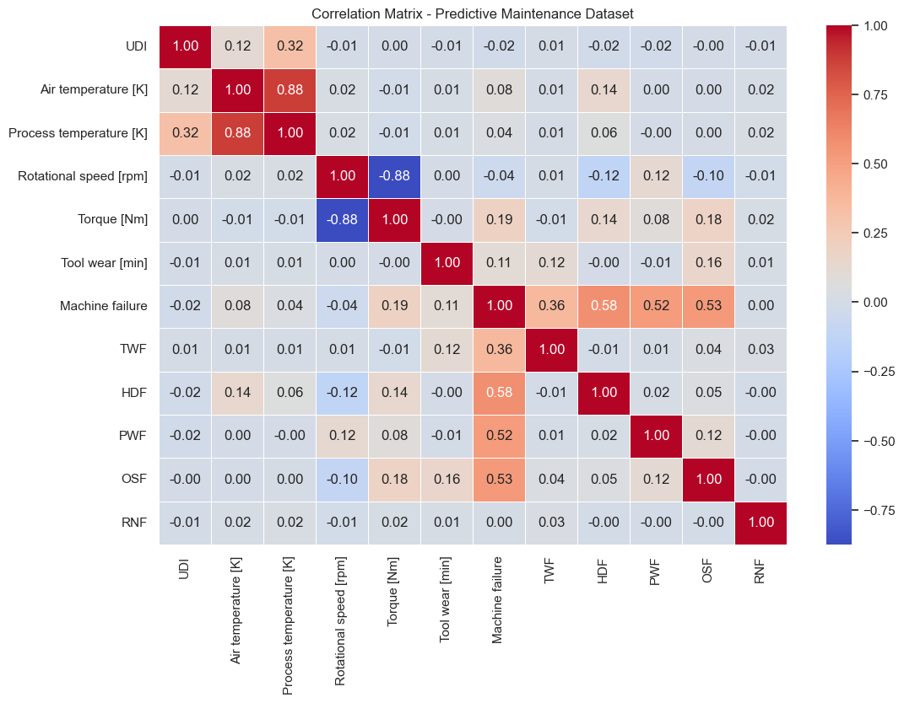
Description:
- This heatmap represents the correlation matrix of all numerical features in the predictive maintenance dataset.
- Both the x-axis and y-axis display the same set of variables, including Air Temperature, Process Temperature, Rotational Speed, Torque, Tool Wear, Machine Failure, and different failure types (TWF, HDF, PWF, OSF, RNF).
- Each cell shows the correlation coefficient between two variables, ranging from -1 to +1:
  - +1 indicates strong positive correlation
  - -1 indicates strong negative correlation
  - 0 indicates no correlation
- The color gradient represents the strength of correlation:
  - Red shades indicate positive correlation
  - Blue shades indicate negative correlation
  - Light/neutral colors indicate weak or no correlation
- The diagonal values are all 1.00, as each variable is perfectly correlated with itself.
Observation:
- Strong positive correlation between:
  - Air Temperature and Process Temperature (~0.88)
- Strong negative correlation between:
  - Rotational Speed and Torque (~ -0.88)
- Machine failure shows moderate positive correlation with:
  - HDF (~0.58)
  - OSF (~0.53)
  - PWF (~0.52)
  - TWF (~0.36)
- Most other variables show weak or negligible correlations.
Interpretation:
- The strong positive correlation between air and process temperature indicates that environmental conditions directly affect machine operating temperature.
- The strong negative correlation between rotational speed and torque reflects the mechanical relationship where higher speeds typically require lower torque.
- Moderate correlations between machine failure and specific failure types indicate that failures are influenced by multiple factors rather than a single variable.
- Weak correlations among many variables suggest that the dataset contains diverse and independent features.
Conclusion:
- Machine failure is a result of multiple interacting parameters rather than a single factor.
- Key relationships such as temperature dependency and torque-speed trade-off are important for understanding machine behavior.
- Correlation analysis helps in selecting important features for machine learning models.
- This graph supports the need for multivariate analysis in predictive maintenance systems.

5.14 Graph: Top 10 Important Features (Feature Importance Bar Chart)
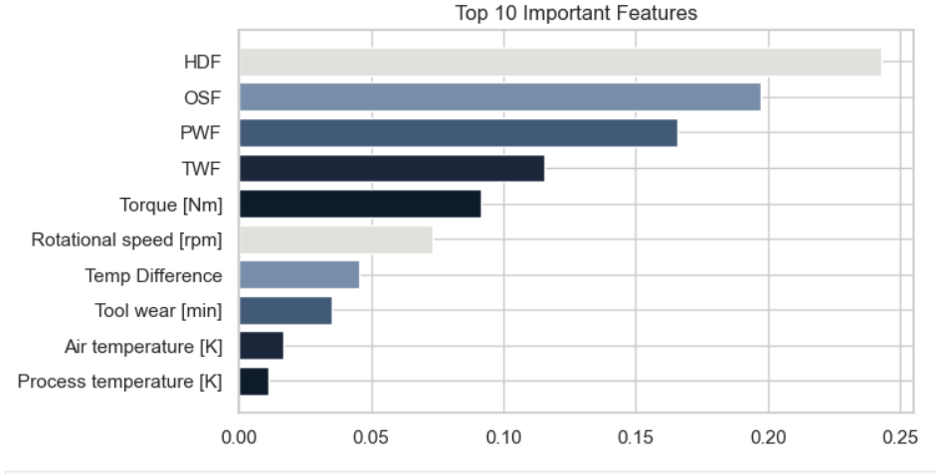
Description:
- This horizontal bar chart represents the top 10 most important features used in the machine learning model (likely Random Forest) for predicting machine failure.
- The y-axis lists the features, including:
  - Heat Dissipation Failure (HDF)
  - Overstrain Failure (OSF)
  - Power Failure (PWF)
  - Tool Wear Failure (TWF)
  - Torque, Rotational Speed, Temperature Difference, Tool Wear, Air Temperature, and Process Temperature
- The x-axis represents the importance score, indicating how much each feature contributes to the model’s prediction.
- Features are arranged in descending order, with the most important feature at the top.
- HDF has the highest importance, followed by OSF and PWF, while temperature-related features have the lowest importance.
Observation:
- HDF (Heat Dissipation Failure) is the most influential feature.
- OSF and PWF also have high importance values.
- Tool-related and mechanical features (Torque, Speed) have moderate importance.
- Temperature variables have relatively low importance.
Interpretation:
- Failure-related features (HDF, OSF, PWF, TWF) strongly influence machine failure prediction.
- Mechanical factors such as torque and rotational speed play a significant role in determining machine performance.
- Environmental factors like air and process temperature have less direct impact compared to operational parameters.
- The model relies more on direct failure indicators and mechanical stress variables rather than environmental conditions.
Conclusion:
- Feature importance analysis helps identify key factors affecting machine failure.
- Monitoring high-importance features can significantly improve predictive maintenance.
- The model emphasizes failure-specific and mechanical variables as primary indicators.
- This insight can help industries focus on critical parameters for maintenance planning.

5.15 Machine Learning Model Performance (Model Result)
5.15.1 Random Forest Classifier
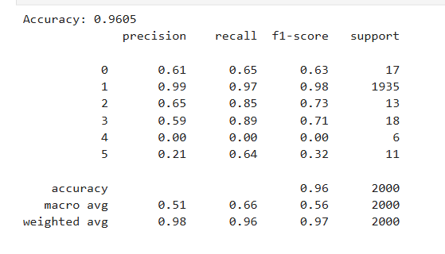
Description:
- The model used for prediction is Random Forest Classifier, trained with parameters such as:
  - Number of estimators: 100
  - Criterion: Gini
  - Max depth: None (full tree growth)
  - Class weight: Balanced (to handle class imbalance)
- The model was evaluated using a classification report, which includes:
  - Precision
  - Recall
  - F1-score
  - Support (number of samples)
Overall Performance:
- Accuracy: 96.05%
- Weighted F1-score: 0.97
- Macro F1-score: 0.56
Class-wise Performance:
Class 1 (Majority Class - Normal Operation):
- Precision: 0.99
- Recall: 0.97
- F1-score: 0.98
- Support: 1935
- Very high performance due to large number of samples
Class 0:
- Precision: 0.61
- Recall: 0.65
- F1-score: 0.63
- Moderate performance
Class 2:
- Precision: 0.65
- Recall: 0.85
- F1-score: 0.73
- Good recall but moderate precision
Class 3:
- Precision: 0.59
- Recall: 0.89
- F1-score: 0.71
- High recall, moderate precision
Class 4:
- Precision: 0.00
- Recall: 0.00
- F1-score: 0.00
Model failed to predict this class (very few samples)
Class 5:
- Precision: 0.21
- Recall: 0.64
- F1-score: 0.32
⚠ Weak performance due to low data
Observation:
- The model performs extremely well for the majority class (Class 1).
- Performance drops significantly for minority classes (Class 4 and Class 5).
- Some classes have very low support (few samples), affecting prediction accuracy.
Interpretation:
- High overall accuracy (96%) is influenced by the large number of normal (non-failure) cases.
- Low macro average (0.56 F1-score) indicates poor performance across all classes equally.
- Class imbalance is a major issue, even though class_weight = 'balanced' is used.
- The model struggles to learn patterns for rare failure types.

5.15.2 Decision Tree
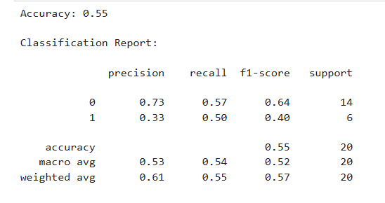
Description:
- The Decision Tree model was trained and evaluated to classify machine failure.
- The model achieved an accuracy of 55%, indicating moderate performance.
- The evaluation was performed using a classification report, which includes precision, recall, F1-score, and support for each class.
Overall Performance:
- Accuracy: 55%
- Macro Average F1-score: 0.52
- Weighted Average F1-score: 0.57
Class-wise Performance:
Class 0 (No Failure):
- Precision: 0.73
- Recall: 0.57
- F1-score: 0.64
- Support: 14
✔ The model performs relatively better for this class.
Class 1 (Failure):
- Precision: 0.33
- Recall: 0.50
- F1-score: 0.40
- Support: 6
⚠ Performance is weak due to fewer samples.
Observation:
- The model performs better for Class 0 (non-failure) compared to Class 1 (failure).
- Precision for failure class is low, meaning many incorrect predictions.
- Recall for failure class is moderate, indicating some failures are detected but not consistently.
Interpretation:
- The lower accuracy (55%) indicates that the Decision Tree model is not highly effective for this dataset.
- The imbalance in class distribution (more non-failure than failure cases) affects model performance.
- The model struggles to correctly classify failure cases due to limited data and simple tree structure.

5.15.3 Model Logistic Regression
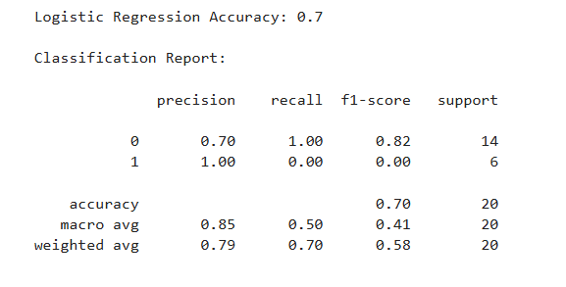
Description:
- The Logistic Regression model was applied to classify machine failure into two classes: 0 (No Failure) and 1 (Failure).
- The model achieved an accuracy of 70%, indicating moderate performance.
- Evaluation was done using a classification report, including precision, recall, F1-score, and support.
Overall Performance:
- Accuracy: 70%
- Macro Average F1-score: 0.41
- Weighted Average F1-score: 0.58
Class-wise Performance:
Class 0 (No Failure):
- Precision: 0.70
- Recall: 1.00
- F1-score: 0.82
- Support: 14
Model predicts non-failure cases very well
Class 1 (Failure):
- Precision: 1.00
- Recall: 0.00
- F1-score: 0.00
- Support: 6
Model failed to correctly identify failure cases
Observation:
- The model performs very well for non-failure cases (Class 0).
- It fails completely to predict failure cases (Class 1).
- High precision but zero recall for Class 1 indicates no correct predictions for failure.
Interpretation:
- The model is biased toward the majority class (non-failure).
- Class imbalance affects the model’s ability to detect rare failure events.
- Logistic Regression assumes linear relationships, which may not capture complex patterns in the dataset.
Conclusion:
- Logistic Regression provides moderate overall accuracy but poor failure detection.
- It is not suitable for predicting rare failure events in this dataset.
- Improvement techniques include:
  - Handling class imbalance (SMOTE, resampling)
  - Using more complex models like Random Forest

5.16 Model Comparison Table
Model | Accuracy | Precision (Avg) | Recall (Avg) | F1-Score (Avg) | Performance Summary
Logistic Regression | 70% | 0.79 | 0.70 | 0.58 | Good for non-failure prediction but failed to detect failure cases
Decision Tree | 55% | 0.61 | 0.55 | 0.57 | Moderate performance, struggled with small dataset
Random Forest | 96% | 0.98 | 0.96 | 0.97 | Best performance, handled imbalance better and predicted accurately

5.17 Overall Insights
From all analyses:
• Tool wear increases failure risk
• High torque overloads machines
• Temperature affects machine health
• Machine type influences reliability
• Failures are rare but costly
These insights help industries plan maintenance strategies.

5.18 Practical Industrial Applications
Predictive maintenance can help industries:
• Schedule maintenance before breakdown
• Reduce downtime
• Improve worker safety
• Optimize spare parts inventory
• Increase machine life
Predictive maintenance is an important part of Industry 4.0 smart factories.

CHAPTER 5–CONCLUSION
6.1 Conclusions
This project successfully demonstrated the application of data analytics and machine learning techniques in predicting machine failures using the AI4I Predictive Maintenance Dataset. The main objective of the project was to analyze industrial machine sensor data, identify important failure factors, and build a predictive model to classify machine failures.
Through Exploratory Data Analysis, important insights were obtained about machine behavior. Tool wear, torque, rotational speed, and process temperature were identified as the most important parameters affecting machine failure. The analysis showed that most machines operate normally, while failures occur rarely but are caused by specific mechanical or thermal issues.
Different machine learning models were tested, and the Random Forest classifier provided the best performance with high prediction accuracy. The model successfully distinguished between normal machine operation and different failure types. This proves that predictive maintenance models can be effectively used to detect machine problems early.
The project also demonstrated strong understanding of the complete data analytics process, including data cleaning, feature engineering, visualization, model building, evaluation, and interpretation. The graphs and statistical analysis helped clearly understand machine failure patterns.
From an industrial perspective, the results highlight the importance of monitoring tool wear, torque, temperature, and speed to prevent machine breakdown. Predictive maintenance systems can help industries reduce unexpected downtime, improve productivity, increase worker safety, and optimize maintenance scheduling. This project is highly relevant to Industry 4.0 smart manufacturing systems.
Although the dataset used was simulated, the observed patterns are similar to real industrial machine behavior. Therefore, the project provides a strong foundation for real-world predictive maintenance applications.
Overall, this project shows that machine learning-based predictive maintenance is an effective solution for improving industrial machine reliability and performance.

6.2 Scope for Future Work
This project can be further improved and extended in several ways.
First, real-time IoT sensor data can be used instead of simulated datasets. Real industrial data will improve model accuracy and make the system more practical.
Second, additional sensor data such as vibration, sound, pressure, and energy consumption can be included. These parameters provide more detailed machine condition information.
Third, advanced machine learning and deep learning models such as Neural Networks, LSTM, and Autoencoders can be used to improve prediction accuracy.
Fourth, Remaining Useful Life (RUL) prediction can be added. Instead of only predicting failure type, the system can estimate how long a machine can run before failure.
Fifth, a real-time dashboard can be developed to monitor machine health continuously and send maintenance alerts automatically.
Sixth, maintenance cost optimization can be added to help industries decide the best maintenance schedule.
Seventh, the model can be expanded to monitor multiple machines in large factories and create a centralized predictive maintenance system.
Finally, integration with Industry 4.0 technologies such as cloud computing, IoT devices, and digital twins can create a fully automated smart maintenance system.

6.3 Final Statement
This project successfully shows how predictive maintenance using data analytics and machine learning can improve industrial efficiency and machine reliability. With further development using real-time data and advanced algorithms, such systems can play an important role in future smart manufacturing environments.

REFERENCES
[1] A. Géron, Hands-On Machine Learning with Scikit-Learn, Keras, and TensorFlow, 2nd ed. Sebastopol, CA, USA: O’Reilly Media, 2019.
[2] J. D. Kelleher, B. Mac Namee, and A. D’Arcy, Fundamentals of Machine Learning for Predictive Data Analytics, 2nd ed. Cambridge, MA, USA: MIT Press, 2020.
[3] T. P. Carvalho et al., “A systematic literature review of machine learning methods applied to predictive maintenance,” Computers & Industrial Engineering, vol. 137, 2019. DOI: 10.1016/j.cie.2018.11.028
[4] T. Zonta et al., “Predictive maintenance in Industry 4.0: A systematic literature review,” Computers & Industrial Engineering, vol. 150, 2020. DOI: 10.1016/j.cie.2020.106889
[5] Y. Lei et al., “Machinery health prognostics: A systematic review from data acquisition to RUL prediction,” Mechanical Systems and Signal Processing, vol. 104, pp. 799–834, 2018.
[6] Scikit-learn Developers, “Scikit-learn Documentation,” Available: https://scikit-learn.org/stable/
[7] Python Software Foundation, “Python Documentation,” Available: https://docs.python.org/3/
[8] Pandas Development Team, “Pandas Documentation,” Available: https://pandas.pydata.org/docs/
[9] Matplotlib Development Team, “Matplotlib Documentation,” Available: https://matplotlib.org/stable/
[10] IBM Corporation, “Predictive Maintenance,” Available: https://www.ibm.com/topics/predictive-maintenance
[11] Elsevier, “Predictive Maintenance – ScienceDirect Topic,” Available: https://www.sciencedirect.com/topics/engineering/predictive-maintenance
[12] S. Zhang et al., “A Survey on Predictive Maintenance,” Available: https://arxiv.org/abs/2001.05538

APPENDIX

pip install pandas numpy matplotlib seaborn
import seaborn as sns
import matplotlib.pyplot as plt
import pandas as pd
import numpy as np
import matplotlib.pyplot as plt
import seaborn as sns
sns.set(style="whitegrid")
df = pd.read_csv("ai4i2020.csv")
print(df.head())
print(df.shape)
print(df.isnull().sum())
print(df.dtypes)
print(df.describe())
print("Duplicates:", df.duplicated().sum())
failure_counts = df[['TWF','HDF','PWF','OSF','RNF']].sum().reset_index()
failure_counts.columns = ['Failure Type','Count']

plt.figure(figsize=(8,5))
ax = sns.barplot(x='Failure Type', y='Count', data=failure_counts)

plt.title("Failure Types Count")

# Add numbers on bars
for p in ax.patches:
count = p.get_height()
ax.annotate(
f'{int(count):,}',
(p.get_x() + p.get_width()/2., count),
ha='center',
va='bottom',
fontsize=10
)

plt.show()
import matplotlib.pyplot as plt
import seaborn as sns

plt.figure(figsize=(10,6))

sns.histplot(df['Process temperature [K]'], kde=True, bins=30)

plt.title('Distribution of Process Temperature')
plt.xlabel('Process Temperature [K]')
plt.ylabel('Frequency')

plt.show()
df['Tool_wear_smooth'] = df['Tool wear [min]'].rolling(200).mean()

plt.figure(figsize=(10,5))
plt.plot(df['Tool_wear_smooth'])
plt.title("Tool Wear Trend")
plt.xlabel("Machine Cycles")
plt.ylabel("Tool Wear (min)")
plt.show()
def get_failure_type(row):
if row['TWF']==1:
return "Tool Wear Failure"
elif row['HDF']==1:
return "Heat Dissipation Failure"
elif row['PWF']==1:
return "Power Failure"
elif row['OSF']==1:
return "Overstrain Failure"
elif row['RNF']==1:
return "Random Failure"
else:
return "No Failure"

df["Failure_Type"] = df.apply(get_failure_type, axis=1)
# Remove No Failure rows
fail_only = df[df["Failure_Type"] != "No Failure"]

# Count failure types
failure_counts = fail_only["Failure_Type"].value_counts()

# Plot pie chart
plt.figure(figsize=(6,6))
plt.pie(failure_counts,
labels=failure_counts.index,
autopct="%1.1f%%")
plt.title("Failure Type Distribution")
plt.show()
plt.figure(figsize=(6,4))
sns.countplot(x='Type', hue='Machine failure', data=df)
plt.title("Machine Type vs Failure")
plt.show()
failure_rate.plot(kind='bar', color='#1A535C')

plt.title("Failure Rate by Tool Wear Level")
plt.ylabel("Failure Probability")
plt.show()
plt.figure(figsize=(6,4))
sns.boxplot(x='Machine failure', y='Tool wear [min]',
hue='Machine failure', data=df,
palette=['#6c757d', '#e63946'], legend=False)
plt.title("Tool Wear vs Machine Failure")
plt.show()
df['Temp Difference'] = df['Process temperature [K]'] - df['Air temperature [K]']

plt.figure(figsize=(6,4))
sns.boxplot(x='Machine failure', y='Temp Difference', data=df)
plt.title("Temperature Difference vs Failure")
plt.show()
plt.figure(figsize=(6,4))
sns.scatterplot(x='Rotational speed [rpm]',
y='Torque [Nm]',
hue='Machine failure',
data=df)
plt.title("Torque vs Speed")
plt.show()
plt.figure(figsize=(6,4))

sns.kdeplot(df[df['Machine failure']==0]['Torque [Nm]'], label='No Failure', fill=True)
sns.kdeplot(df[df['Machine failure']==1]['Torque [Nm]'], label='Failure', fill=True)

plt.title("Torque Density by Machine Failure")
plt.legend()
plt.show()
import matplotlib.pyplot as plt

columns = ['Air temperature [K]',
'Process temperature [K]',
'Rotational speed [rpm]',
'Torque [Nm]',
'Tool wear [min]']

colors = ['blue', 'green', 'red', 'purple', 'orange']

plt.figure(figsize=(12,8))

for i, col in enumerate(columns):
plt.subplot(3, 2, i+1)
plt.hist(df[col], bins=30, color=colors[i])
plt.title(col)

plt.tight_layout()
plt.show()
# Select only numeric columns
numeric_df = df.select_dtypes(include=['int64', 'float64'])

# Create correlation matrix
correlation_matrix = numeric_df.corr()

# Plot correlation heatmap
plt.figure(figsize=(12,8))
sns.heatmap(correlation_matrix,
annot=True,
cmap='coolwarm',
fmt='.2f',
linewidths=0.5)

plt.title("Correlation Matrix - Predictive Maintenance Dataset")
plt.show()
sns.pairplot(df[['Air temperature [K]',
'Process temperature [K]',
'Rotational speed [rpm]',
'Torque [Nm]',
'Tool wear [min]',
'Machine failure']],
hue='Machine failure')
plt.show()
palette = sns.color_palette("Set2")

for i, col in enumerate(features):
plt.figure(figsize=(5,3))
sns.boxplot(x=df[col], color=palette[i])
plt.title(f"Outliers in {col}")
plt.show()
from sklearn.ensemble import RandomForestClassifier

X = pd.get_dummies(df.drop(['UDI','Product ID','Machine failure'], axis=1))
y = df['Machine failure']

model = RandomForestClassifier(random_state=42).fit(X, y)

top10 = pd.Series(model.feature_importances_, index=X.columns)\
.nlargest(10).sort_values()

colors = ['#0d1b2a','#1b263b','#415a77','#778da9','#e0e1dd']*2

plt.figure(figsize=(7,4))
plt.barh(top10.index, top10.values, color=colors[:10])
plt.title("Top 10 Important Features")
plt.show()

